**INDIA AGRICULTURE CROP PRODUCTION ANALYSIS (1997-2021)**

**PROJECT REPORT**

**1.INTRODUCTION**:

**1.1 OVERVIEW:**

First, I created an EMPATHY MAP. A map has four quadrants (says, Thinks, Does and Feels). What are the difficulties farmers face to get the yield. And also, I included some steps & methods to increase the yield. Next, I created the BRAINSTORM. Here team leader and team members discuss how the crops face problems due to the insects & give the solutions to get good yield. Our problem statement is “Why farmers do not get good yield in Crop Production”. Next, I created my Data Analysis-Dashboard and Story after I published my Dashboard & story in Tableau Public.

* 1. **PURPOSE:**

Data Analysis help a business optimize its performance, perform more efficiently, maximize profit, or make strategically-guided decisions. The techniques and processes of data analytics have been automated into mechanical processes and algorithms that work over raw data for human consumption.

**2. PROBLEM DEFINITION & DESIGN THINKING:**

**2.1 EMPATHY MAP:**

An empathy map is a collaborative tool teams can use to gain a deeper insight into their customers. Much like user persona, an empathy map can represent a group of users, such as a customer segment. The empathy map was originally created by Dave Gray and has gained much popularity within the agile community.

An empathy map is a tool used in design thinking to build an emotional representation of a user or the customer. It is versatile activity that may be used to generate new product ideas as well as better understand existing ones.

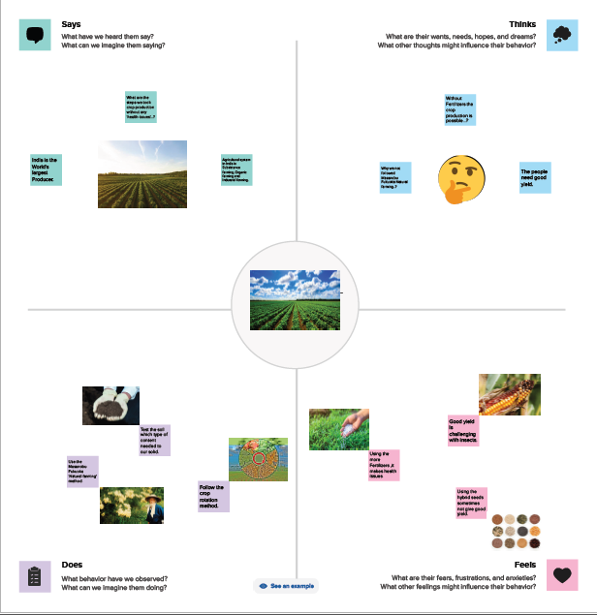

**2.2 IDEATION & BRAIN STORMING MAP:**

Brainstorming is a group problem -solving method that involves the spontaneous contribution of creative ideas and solutions. This technique requires intensive, freewheeling discussion in which every member of the group is encouraged to think aloud and suggest as many ideas as possible based on their diverse knowledge.

These principles led Osborn to establish, withhold criticism, welcome unusual ideas, and combine and improve ideas.

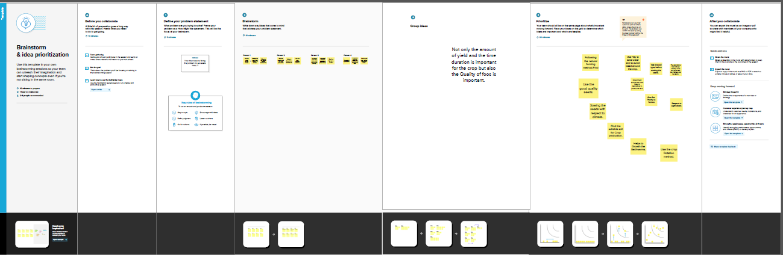

**3.RESULT:**

**DASHBOARD 1:**

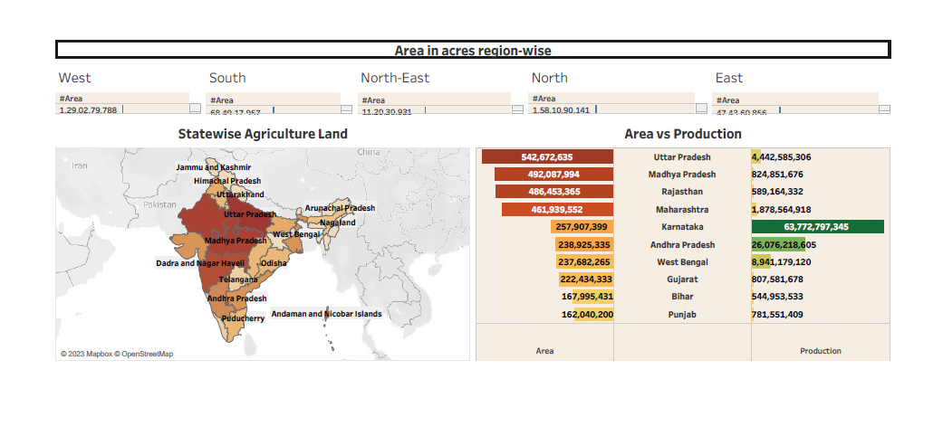

**DASHBOARD 2:**

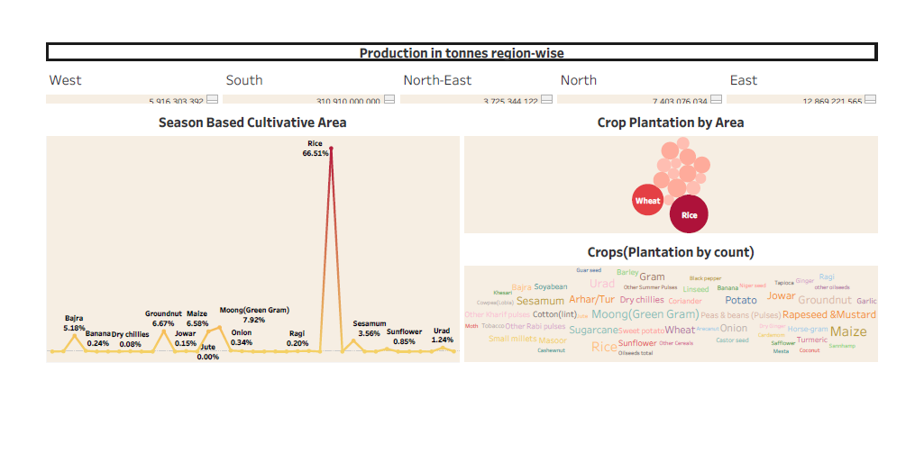

**DASHBOARD 3:**

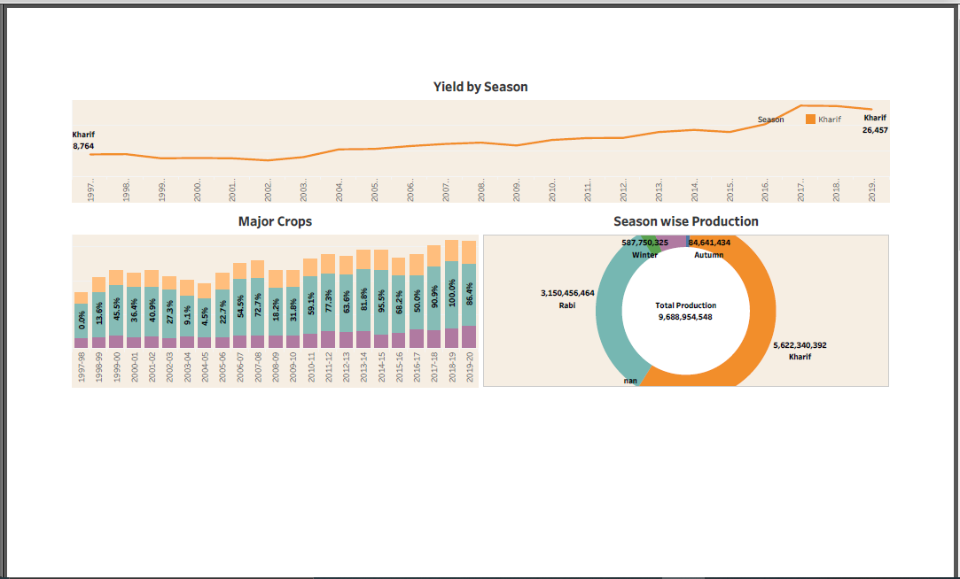

**STORY 1:**

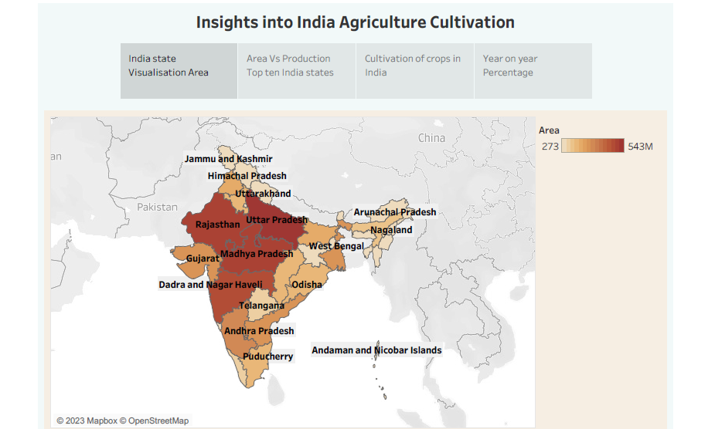

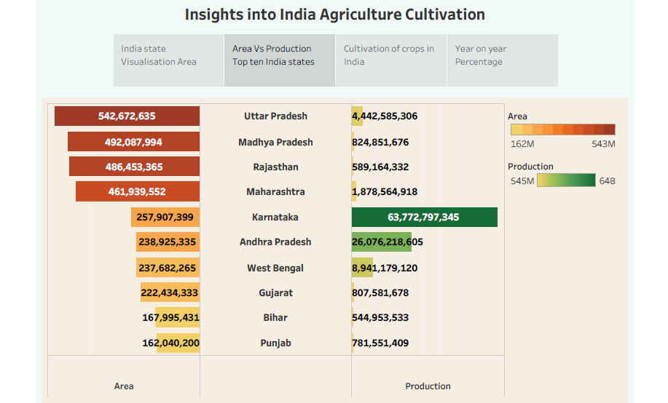

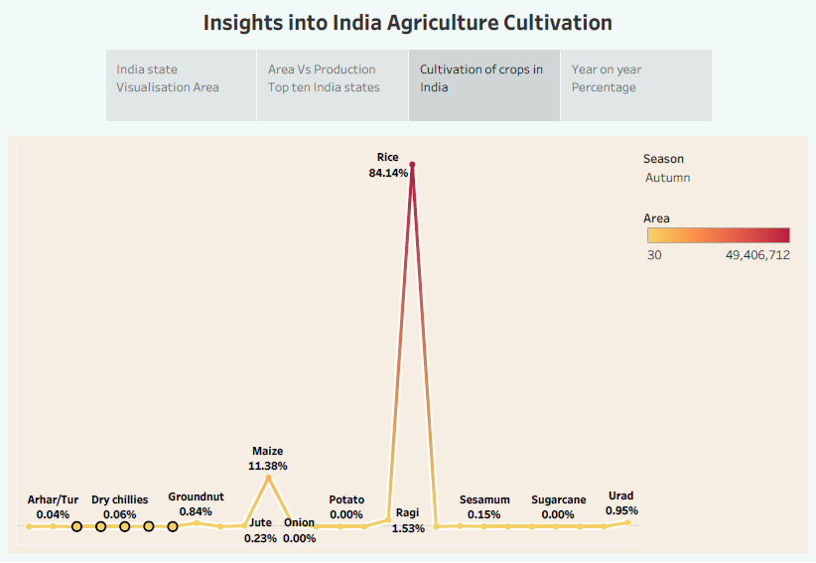

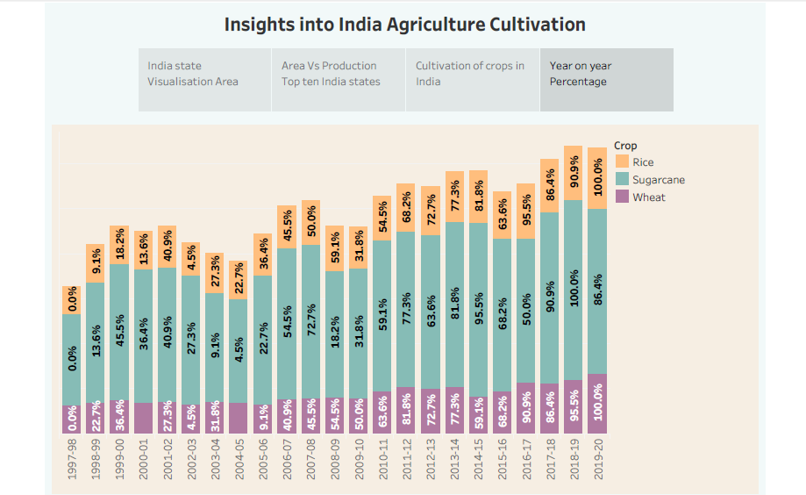

**STORY 2:**

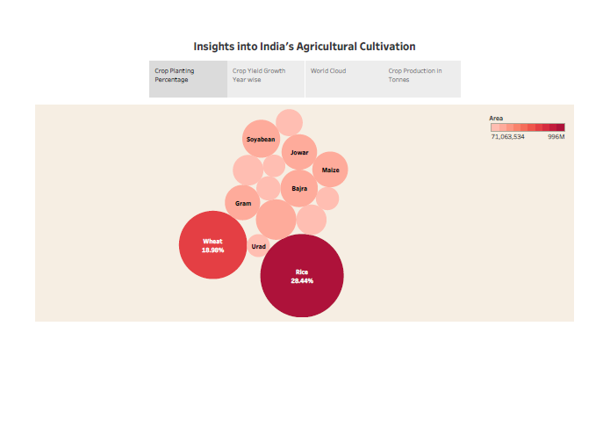

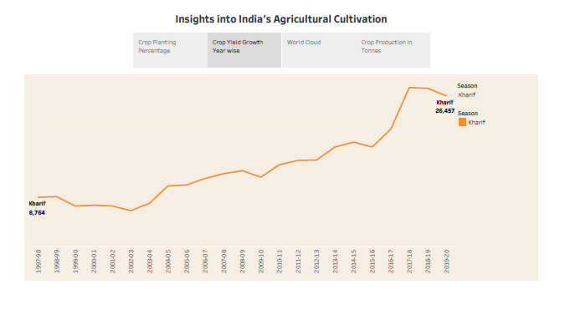

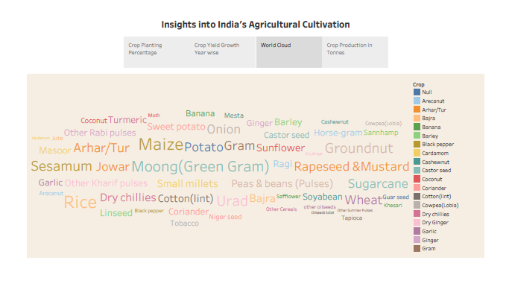

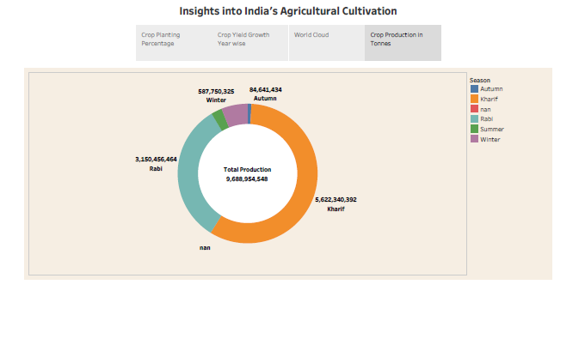

**4. ADVANTAGES & DISADVANTAGES:**

**ADVANTAGES:**

India is the second largest producer of wheat and rice, the world’s major food staples. India is a currently the world’s second largest producer of several dry fruits, agriculture-based textile raw materials, roots and tuber crops, pulses, farmed fish, eggs, coconut, sugarcane and numerous vegetables.

India has some great advantages for agriculture. India has more than 20 agroclimate regions, where sunlight hours and day length are suited for round the year cultivation. If we analyse the crop production, we can gate good yield.

**DISADVANTAGES:**

* Use more fertilizers for getting good yield, it causes the human being health.
* The fertilizers act inside the human being like a slow poison.
* After analysing the agriculture, we use Modern forming methods. It is had overused the natural resource base.
* The present challenges that plague Indian agriculture are limited knowledge and insufficient infrastructure.

**APPLICATION:**

* Data Analytics can be used by policymakers to enhance learning curriculum and management decisions.
* Data Analytics converts raw data into actionable insights.
* Through the data analysis we can improve our knowledge.

**CONCLUSION:**

In the Data Analysis we analyse the Crop production through the Empathy map and Brain storming. In the Empathy map First, we say what is our problem and next we give some ideas about the problems. We also include what people thought about our ideas.

Next, we create the sheets for analysing the datas. In the Data analysis we create many useful things regarding development of agriculture. Also, we analyse the state wise yield, season-based cultivation and so on.

**SCOPE:**

Data Analysis is developing the agriculture field. In the data analysis we give some ideas, it is used to improve the agriculture field. It’s leads to best yield. Because Agriculture is part of India’s Economy.